Content

(Intro) 4

How many kites have been built since 1929? 4

The beginning – Who were the first kite builders? 5

Constructions 6

Countries 8

Germany - 1930 8

Denmark 1931 8

Switzerland - 1935 8

Netherlands -1935 8

Great Britain 1936 8

Belgium – 1937 8

USA and Canada- 1949 8

Finland – 1947 8

France - 1950 9

Australia – 1950 9

Austria - 1963 9

Werftportraits 10

Germany 10

F. Mello, Hamburg (1934-1942) 10

Abeking & Rasmussen (1935-1971) 10

Erich Schaal (c. 1950 - c. 1985) 10

Willy Lehmann (1950 – 1972) 11

Rambeck (1950 – 1963) 11

Markus Glas Boatyard (1967 to present) 11

Austria 14

Bootswerft J.&K. Haitzinger (1963 – 1970) 15

Johann Ratz (1963) 16

Switzerland 17

Bootswerft Müller AG (1946 – 1966) 17

Yachtwerft Wirz AG (1955–2003) 19

International 22

Anker & Jensen (1930) 22

Werft Børge Børresen, Dänemark (1935 - 2006) 23

Pedersen & Thuesen (1952-1970) 24

Mikko's List 25

Dragon Nests: An Attempt at an Inventory

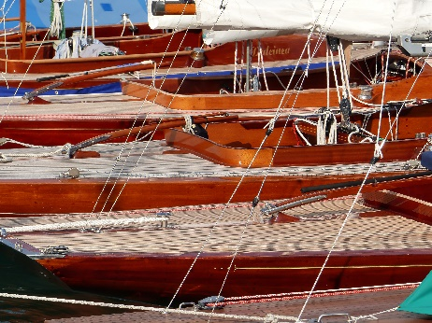 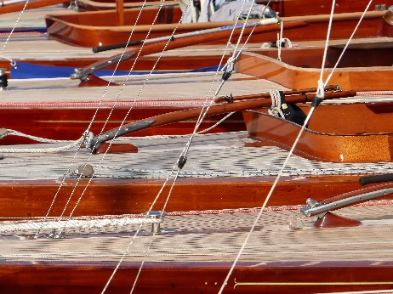 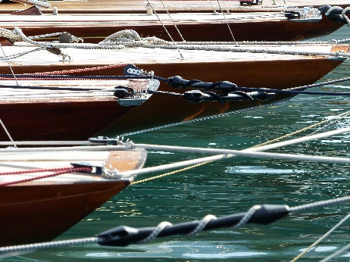

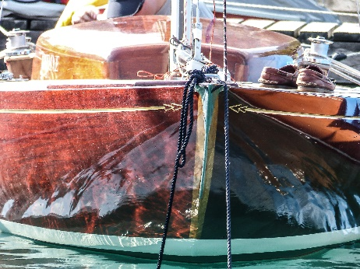 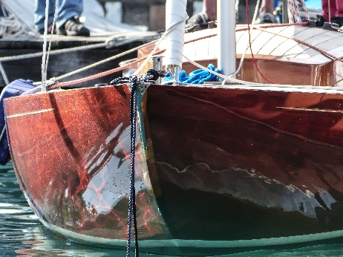 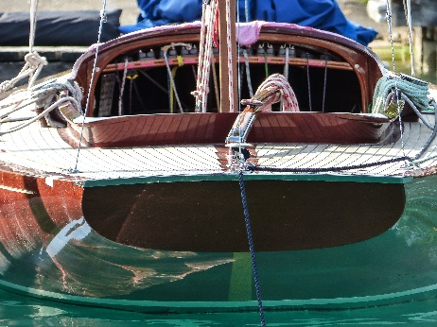

A picture that contains outside, boat, ship, water.

Auto-generated description 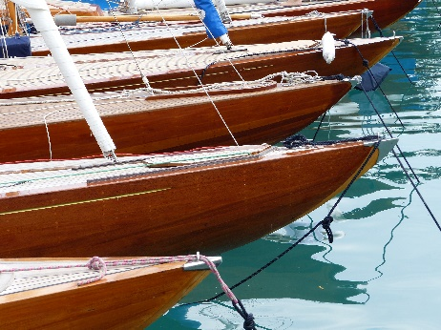 A picture that includes outside, watercraft, sailboat, transportation.

Auto-generated description

An image containing sailboat, sailing, outdoors, person.

Auto-generated description 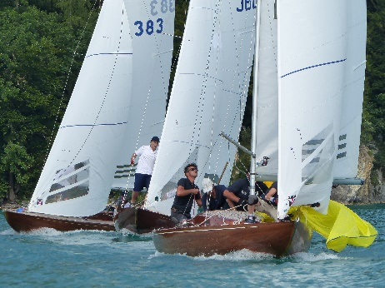 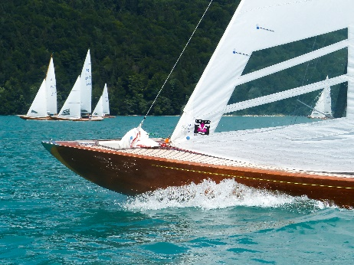

An image that includes sailing ship, sailboat, outside, transportation.

Auto-generated description 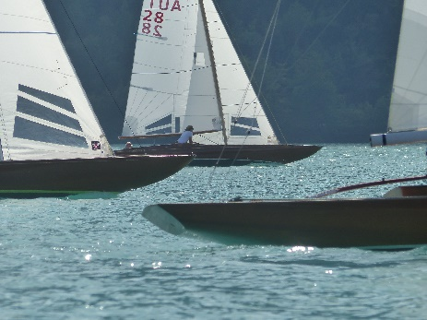 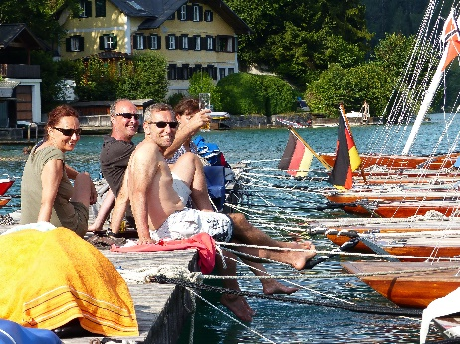

An image that includes outdoors, sailboat, sailing, watercraft.

Auto-generated description

Photographer Marcus Oppitz

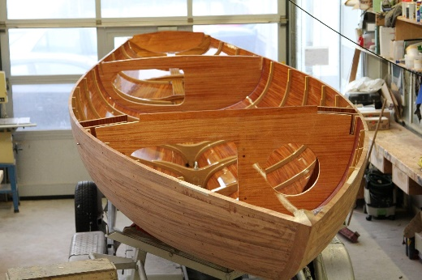 An image that contains In The House, Wooden, Wood.

Auto-generated description An image that contains In House, Wooden, Floor, Wood.

Auto-generated description

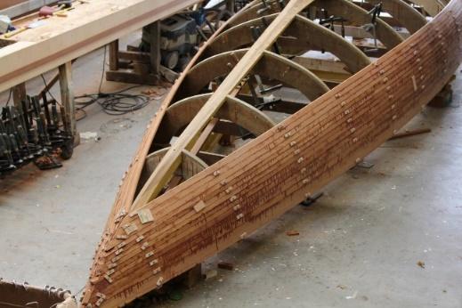 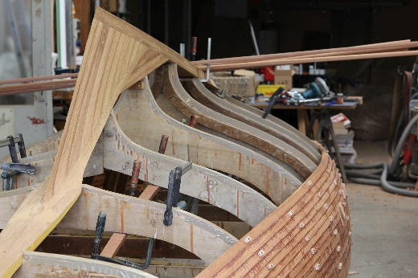 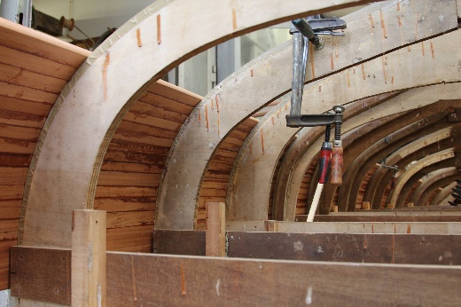

Facebook-Archiv Bootswerft Glas

# Introduction

When we discussed the content of the DRAGON JOURNAL 2021 in the fall of 2020, it was already clear that current sailing events would take up little space. The idea of using the space for larger topics from class history was obvious and the suggestion to portray classic dragon shipyards was immediately approved. After a short research, we came across a list of dragon boat shipyards that Mikko Jaatinen from Finland had already compiled a few years ago. We could hardly believe our eyes when we realized that the list contained about 300 entries from over 20 countries. There we sat in front of this list and had to decide how to approach the matter. Do we want to give preference to the oldest shipyards or focus on the most well-known? Where can I find detailed information about boat builders who no longer exist? Is the number of boats built a selection criterion? The decision we then made is a compromise: we selected shipyards from each of the 3 countries (Germany, Switzerland, Austria) and added some well-known international names to this list. So if the esteemed reader does not find "his" boatyard portrayed, this is not a sign of disrespect, but solely due to the limit of space and time. As a consolation, however, we have included Mikko's list and thus provided a basis for further research and perhaps also valuable additions.

*Marcus Oppitz, Gregor Berz, Garlef Baum*

## How many Dragons have been built since 1929?

As of today, the IDA has just over 1300 boats registered in the national class associations. This would have to include the number of unregistered boats (the number of unreported cases) and, of course, the number of boats that no longer exist. The construction figures give an indication. If you add only the known construction figures of the larger Dragon shipyards since 1929, you get about 2200 boats:

|  |  |  |  |  |
| --- | --- | --- | --- | --- |
|  | Years of construction | Number of wood (approx) | Number of GRP (approx) | Total (approx) |
| Anker & Jensen | 1930-1953 | 48 |  | 48 |
| Børresen | 1935-2006 | 325 | 425 | 750 |
| Abeking & Rasmussen | 1934-1966 | 136 |  | 136 |
| Miller | 1946-1966 | 66 |  | 66 |
| Pedersen & Thuesen | 1952-1970 | 97 |  | 97 |
| Chantier G. Bonnin frères | 1950-1968 | 74 |  | 74 |
| Yachtwerft Wirz AG | 1956 – 2003 | 203 |  | 203 |
| Markus Glas | 1967 – present | 16 | 200 | 200 |
| Petticrows | 1988 – today |  | 700 | 700 |
| TOTAL |  |  |  | 2274 |

In addition, the - largely unknown - construction figures of the other approximately 280 shipyards in Mikko's list must be counted. A rough estimate of the total number of Dragons built since 1929 will probably be around 3000 boats. On an annual average, a good 30 Dragons were created in 90 years. The IDA statistics note a total of 397 new Dragons for the years 2007-2020, which corresponds to the annual average of about 30 new boats per year.

## The beginning – Who were the first Dragon builders?

In 1928, the Swedish Royal Gothenburg Yacht Club (GKSS) announced a design competition. What was required was a design for "a mass-produced, cost-effective standard boat for youth". Although Johan Anker is not convinced by the idea of the one-design classes, he decides to participate. His design of the Dragon was declared the winner and published on December 25 1928, in the "Seglerbladet", the magazine of the GKSS.

An image that contains text, paper, newspaper, document.

Auto-generated description

*The "Seglarbladet" of December 25, 1928*

The first boats based on Johan Anker's 1928 design were built in Sweden and Norway in 1929. It was not Johan Anker's shipyard Anker & Jensen that laid the first keel, but the Swedish shipyard Hjalmar Johanssons båtvarv in Gothenburg. In 1929, Hjalmar Johansson was commissioned by the Gothenburg Royal Sailing Society (Göteborgs Kungliga Segelsällskap - GKSS) to build the first three Dragons. In Gothenburg in 1929, the first three examples were launched in at the GKSS.

An image that contains outside, ship, sky, boat.

Auto-generated description

*The first 3 Dragons in 1929 in the harbour of the GKSS*

The Swedish boatyard Bernhard Palssons followed in the same year. The Dragon also made its debut as a regatta boat in 1929 at the Marstrand Regatta of the GKSS. Also in 1929, the first two Norwegian Dragons N1 and N2 were built at the Hvidtsen shipyard in Norway.

The list of the first shipyards from 1929 to 1930 therefore contains half a dozen names:

|  |  |  |  |
| --- | --- | --- | --- |
| 1929 | Hjalmar Johansson's boatyard | Sweden | Gothenburg |
| 1929 | Hvidsten Boatbuilding | Norway |  |
| 1929 | Bernhard Palssons | Sweden |  |
| 1930 | W.v.Hacht | Germany | Hamburg |
| 1930 | Anker & Jensen | Norway | Full |
| 1930 | (Robert?) Holmen båtbyggeri A/S. | Norway |  |

## Construction

The first Dragons were built in carvel construction. It was not until the 1980s and 1990s that the more modern cold moulded process and the strip construction method became established.

**Carvel-planking**

In the Carvel construction method (Middle Low German from Portuguese Caravela), the planks (in contrast to the clinker construction) are attached edge to edge. This gives the hull a smooth surface.

**Strip planking**

A framework of bulkheads and auxiliary frames is planked with strips glued together. This method produces a high longitudinal strength, the transverse and diagonal strength comes from the bulkheads and frames.

**Cold Moulding**

Three to six layers of thin wood veneers are glued together alternately diagonally, lengthwise and crosswise over a framework of auxiliary frames and stringers. The result is a hull of high strength that is almost self-supporting and requires a minimum of stringers and frames.

Dragons were built until 1946 according to the original Anker design (A Dragon). Then there was a reform of the Dragon rig, with the mast moved further forward, the A Dragon became the B Dragon and from 1948 was an Olympic Class. In 1972, GRP Dragons were finally approved by the IDA. Borge Børresen was behind this reform, and he told this story on the occasion of the Danish Championships in 2004.

Speech on the dragon story by Børge Børresen on the occasion of the Danish Championships 2004, translated by Lars Hendriksen:

*Your Royal Highness – Ladies and Gentlemen*

*Lars Hendriksen have asked me to tell a little about the history of the Dragon. I am now so old that no-one can control if what I am about to tell is true. For sure the order of what I will tell you is super accurate. It is hard to remember exactly what happened after so many exciting years in the Dragon.*

*I was told that in the year 1928 some wealthy yachtsmen in Gothenburg was looking for a cheap boat for their kids as a alternative to the 6 meters and other meter yachts. Johan Anker was asked to design such a boat for them and that was the beginning of the Dragon. The first Dragon was built in Sweden in 1929 (I was 10 years old by then). Now we are here 75 years later. Very soon after the first Dragons came to Denmark. Originally the Dragon was built with a large cockpit and a small open cabin top with two benches so the youngsters could sleep over on the boat. In 1933-34 I sailed in a Dragon with a school mate of mine, in DD 14, that his father gave him, we were both 14-15 years old at the time.*

*Soon the Dragon was developed to a yacht with a larger cabin roof, real beds, and a pantry. The Dragon was sailed and raced all over Denmark on Øresund and spread over the country especially in Svendborg, Århus, Vejle, Svendborg, Kolding and so on.*

*My brother and I build our first Dragon in 1935-36 – we were 16-17 years at the time. It was also a Dragon with a cabin. Later we discovered that the mast position was free, so after having sailed DD 14 for some time, we concluded that it had too much rudder pressure and we moved the mast 6 cm forwards.*

*The measurer Ingemar Ferdinen G. Hansen said we were totally crazy to move the mast as the boat was designed by the notorious Johan Anker and of course Johan Anker would not make a mistake when placing the mast on the original drawings! We sold the Dragon to Svendborg and the boat later won almost everything. If it was because of the mast position or the skilful young helmsman, Niels Victor is hard to say?*

*Later we all experimented a lot with the mast position and the heeling of the mast, sheet positions and so on. In 1946 the Dragon was modernized with a higher fore triangle and two spreaders, a bigger genoa and a spinnaker. It qualified the Dragon to be selected as a Olympic boat in England 1948. That was the end of the ”luxurious” cabin Dragons.*

*Now it became a clean racing yacht, and the development went back to the large cockpit as it was in the originally design. Later it was allowed to build in mahogany and to replace the cotton covered deck with a teak deck. Also, the aluminium mast was introduced and sails made of Dacron and additional more trim options. Only - all this did not make the Dragon any cheaper!*

*The Dacron sail meant that we could sail with full genoa and mainsail even in strong winds. Originally, we used cotton sails. We had two genoas, a big and a small one and even a storm jib. I remember having sailed with the main rolled 8 times around the boom and a storm jib.*

*The IDA was established in 1962 In order to manage and control Class Rules and the changes of the Class Rules.*

*After a lot of preparations, I managed to get the Class Rules for GRP Dragons approved by the IDA in 1977 (probably 1972, Anmerkung der Redaktion). It was done to make it cheaper to produce a Dragon and because the number of wooden boats build was declining. We also hoped to keep the Dragon in the Olympics. Despite our efforts the Dragon lost its Olympic status in 1972, but it turned out not to harm the Dragon class, on the contrary it is now more popular than ever before.*

*BB*

## Countries

### Germany - 1930

The first Dragon in Germany, D G 1, was built in 1930 by **W.v.Hacht** in Hamburg. Since the yacht archive of the DSV was lost in the war, we know very little about the German Dragons of the pre-war years. For example, D G 8 from 1938 is the only other Dragon of which we can assume today that it also comes from W.v. Hacht. From 1932 onwards, the Kiel shipyard **B. Wielke** was added, and from 1934 the Hamburg shipyard **F. Mello**, with Mello alone building at least 16 Dragons in the pre-war years, including D G 2. As a result, Dragons are built at over 30 boatyards in Germany.

### Denmark 1931

In Denmark, the **Broderna Andersen** shipyard built the first Danish Dragon in 1931. By the end of the 1930s, 10 more shipyards followed, including **Børresen** in Vjele in 1935. After the war, a good dozen Danish shipyards set about building Dragons, including **Pedersen & Thuesen** in 1952.

### Switzerland - 1935

In Switzerland, Dragons have been built since the mid-1930s by the Yachtwerft **Portier AG** and **Boesch**, both on Lake Zurich, Furer **Bootbau AG,** Lake Thun, and Bootswerft **Rohn AG** on Lake Biel. After the war, the **shipyards Stäheli & Tschumper**, the Müller AG boatyard on Lake Thun and the Wirz AG **yacht yard**  on Lake Constance were added.

In the heyday of the Dragon with Olympic status (until 1972), 22 percent of the world's Dragon production was built in Switzerland. By 2003, more than 250 Dragons had been produced by shipyards based in Switzerland. The shipyards Müller and Wirz build extraordinarily beautiful boats, veritable "pieces of furniture", so to speak. However, both miss the change of the Dragon from a piece of furniture to a regatta boat, i.e. the consistent and uncompromising orientation in terms of weight and layout to regatta sailing.

### Netherlands -1935

In the Netherlands, Van de Staadt laid down the first Dutch Dragon in 1935. Today's best-known Dutch Dragon shipyard, **Doomernik,**  built the first Dragon in 1996.

### Great Britain 1936

In 1936, **McGruer & Co Ltd**. and **Alexander Robertson** built the first British Dragons in Scotland. More than a dozen more Dragon shipyards in Great Britain followed in the next decades. Petticrows, now the most famous UK shipyard, built its first Dragon in 1988.

### Belgium – 1937

In Belgium, the first Belgian Dragon was built **in 1937 by** Chantier naval de Kuypers.

### USA and Canada- 1949

The first individual Dragons were built in the USA at the end of the 1940s. U.S. and Canadian shipyards did not produce larger numbers until the 1960s and 1970s.

### Finland – 1947

The Finnish shipyard **Valkon Laiva Oy** laid down its first Dragon in 1947.

### France - 1950

In France, the Atlantic coast around Arcachon and La Rochelle is developing into a Dragon stronghold. The first French Dragon was built in 1950 by **Chantier G. Bonnin frères** in Arcachon.

### Australia – 1950

The first Australian Dragon was built in 1950 by **J. J. Savage & sons Pty. Ltd.** in Melbourne

### Austria - 1963

The first Dragon did not come to Austria until 1954. From 1963 onwards, the boat builders **Haitzinger** on Lake Attersee and **Johann Ratz** on Lake Wolfgang built Dragons for the sailors in the Salzkammergut (see shipyard portraits).

# Shipyard Portraits

## Germany

### F. Mello, Hamburg (1934-1942)

As early as the 1920s, Franz Mello built dinghy cruisers and J-dinghies in Hamburg and added the Dragon to the range in 1934 with the construction of the D G 2 "Piet Hein". Mello Dragons were characterized by their round mirror and, according to Günter Ahlers, were considered the "fast" ones before the war. Today, the yachts D G 2, 4, 6, 7, 9, 14, 15, 16, 17, 18, 25, 27, 29, 33, 35 and 36 have been handed down to us as Mello Bau, some of which were delivered to Bavaria and Lake Constance. The Mello shipyard, which can probably be considered the most important Dragon shipyard in Germany before the war, was bombed out in 1942. After the war, it resumed operations, but no longer built Dragons.

### Abeking & Rasmussen (1935-1971)

Rasmussen already had experience in the construction of 6-Metre-R yachts, among other things, when he founded Abeking & Rasmussen Works in Lemwerder in 1907 together with Georg Abeking, who was financially stronger. Himself a successful regatta sailor, he built everything that sailing needs in the following years, from standard classes such as Star boats to Metre-R yachts of all sizes to the famous Germania III from Krupp. In the years 1935 to 1971, Abeking & Rasmussen built 186 Dragons alone. The first Abeking & Rasmussen Dragon in 1935 was the D G 10 "Woge VI" of O. Ernst, Hamburg, which still sails on Lake Traunsee today. The last five "Dragon Boats", as they are called in the Abeking & Rasmussen construction number book, were registered as "not finished" in 1971 – when the era of the GRP Dragon began.

Pictures of Abeking & Rasmussen

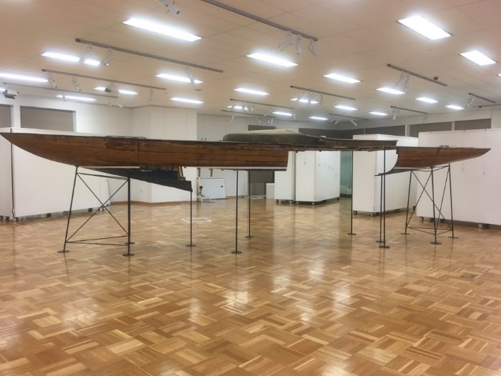

The Abeking & Rasmussen Dragon GER 138 Gustel XI has made it to a museum in Australia (Wanneroo Art Gallery) after winning the Gold Cup with Theordor Thomson in 1955 and being sold there in 1956 after the 1956 Olympics in Melbourne. Photo: John Low/Jeff Sinton

### Erich Schaal (c. 1950 - c. 1985)

Erich Schaal was already interested in Dragons in the 1930s, at that time still an employee of the Klaus Engelbrecht shipyard in Berlin. After the war, he began to build Dragons for the Western market in his private shipyard in East Berlin - not only for West Germany but also for Denmark and Switzerland, for example. In the 1950s, most of the approximately 60 Dragons he built over the course of his life were created. In 1958, Schaal fled to West Berlin during the transfer of two Dragons and built about one high-quality Dragon a year there, first in Neuköln and later in Heiligensee, until the 1980s.

### Willy Lehmann (1950 – 1972)

Also in the 1950s, Willy Lehmann built his first two Dragons in East Berlin. However, as long as the 5.5 was Olympic, the Lehmann shipyard focused on the very successful construction of 5.5 meter yachts. Only then did Lehmann take over the construction of the Dragons of the Olympic GDR sailors. Most of the 50 or so Dragons that were built in the GDR until 1972 - as long as the Dragons was Olympic - are Lehmann kites. Many of them still sail on the Scharmützelsee today, mostly converted into cruising Dragons.

By the way, the Dragon with which all Olympic medals of the GDR dragon sailors were won - silver in 1964 by Peter Ahrens from Rostock, bronze by Paul Borowski in 1968 and silver again in 1972 on the same yacht by Borowski - was neither a Lehmann nor a Schaal construction: The D G (East) 37 Mutafo was built in the PGH Müggelspree, where only a few Dragons were built.

### Rambeck (1950 – 1963)

Founded in 1883 by Anton Rambeck, the Rambeck shipyard was the largest shipyard in southern Germany before the First World War as a "purveyor to the court" of the Bavarian Yacht Club. When Anton Rambeck died in 1912 without descendants, his brother-in-law Anton Dreher took over the Rambeck shipyard, which is still run by the Dreher family under its original name and has now built over 2,200 boats – sailing yachts and motorboats in wood and of all sizes. After only a few Dragons had strayed to Lake Starnberg before the Second World War, Anton Dreher began to build his first Dragon here in 1949, GER 108 (measured in 1950). By 1963, 11 Dragons had been built at Rambeck, which may be considered a bit heavy, but all the more solid.

### Markus Glas Boatyard (1967 to present)

In 1924, Markus Glas's grandfather, a trained wheelwright, began to build dinghies, fishing barges and dinghy cruisers on Lake Starnberg in the first generation. Wooden Dragons have been built since 1967. 16 wooden Dragons and, from 1980, also about 200 GRP Dragons were built in Possenhofen.

The grandson of company founder Markus "Buale" Glas has been successfully sailing Dragons himself since the 70s, helping his own boats to gain a reputation. He became world champion in Travemünde in 1981 and was European Champion a total of six times and is a 12-time German champion. In 1977, at the age of 22, he stood at the top of the podium for the first time at the European Championships in Dournanez. On board are Mucki Binder and Walter Nickol, then an apprentice in the Glas shipyard. Mucki Binder later recounts: "We actually wanted to sail FD, but Father Glas' shipyard built Dragons – and not FDs. Buale was 22, I was 26. We were the youngest European Champions ever in the Dragon."

In 1990, a cooperation with the Austrian shipyard Frauscher began. By 2013, the hulls, inner shells and decks for 82 Glas Dragons will be manufactured in Gmunden am Traunsee. But the construction of wooden Dragons will not be stopped either. Until 2016, wooden Dragons will still be built in Possenhofen (see pictures). In the meantime, Markus Glas' son Max has taken over the helm in the fourth generation.

Pictures of Glas:

An image that contains text, building, outside, house.

Auto-generated description An image that contains outside, water, sky, watercraft.

Auto-generated description 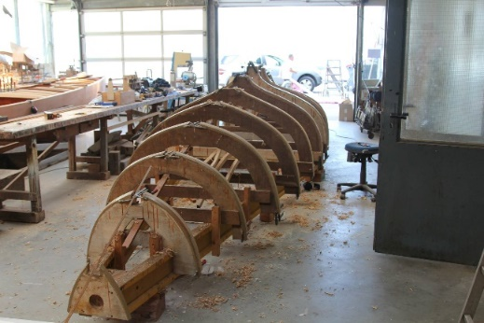

 An image that contains In House, Wooden, Floor, Wood.

Auto-generated description An image that includes outside, vehicle, boat, boat trailer.

Auto-generated description

*Photo: Archiv Bootswerft Glas*

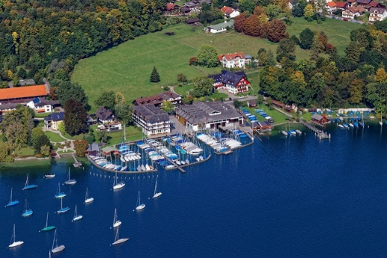

*Photo: Oliver Betz*

Glas Wooden Dragons

|  |  |  |
| --- | --- | --- |
| 1967 | G387 | Karweel |
| 1969 | G394 | Karweel |
| 1973 | G464 | Karweel |
| 1978 | G543 | Karweel |
| 1979 | G562 | Karweel |
| 1988 | G716 | Cold |
| 1992 | G775 | Strip |
| 1993 | G801 | Strip |
| 1993 | G803 | Cold |
| 1994 | G824 | Cold |
| 1994 | G829 | Cold |
| 1994 | G831 | Strip |
| 2002 | G975 | Strip |
| 2004 | G998 | Strip |
| 2005 | G1018 | Strip |
| 2016 | AUT (Wolfgangsee) | Strip |

## Austria

At the beginning of the 60s, Austrian boat builders also began to build Dragons. In 1960, there were about half a dozen Dragons in Austria. By 1970, this number rose to about 40 boats. More than a third of this came from domestic production.

|  |  |  |  |  |  |  |  |
| --- | --- | --- | --- | --- | --- | --- | --- |
|  |  | Name | Shipyard | Year of construction | Yacht register | Owner | Club |
| Car specs | 1 | DIAMOND | Abeking & Rasmussen/GER | 1953 | 1954 | Heldwein, Mag. Anton | UYCAS |
| Car specs | 2 | ADRIENNE | Abeking & Rasmussen/GER | 1937 | 1956 | Ratz, Johann | UYCWg |
| Car specs | 3 | MARISSA | Abeking & Rasmussen/GER | 1957 | 1957 | Anzinger, A. | UYCWg |
| Car specs | 4 | MONSOON | H. Wirz/SUI | 1954 | 1958 | Renn, Rudolf | UYCAS |
| Car specs | 5 | HENRY |  | 1942 | 1959 | Denk, Dr. G. | UYCAS |
| Car specs | 6 | HELESTA | Johann Ratz/AUT | 1963 | 1963 | Stelzer, Erich | UYCAS |
| Car specs | 7 | CHERIE | Johann Ratz/AUT | 1964 | 1964 | Besler, Ing. Harald | UYCAS |
| Car specs | 8 | MARINA | Bjarne/NOR | 1960 | 1964 | Seeman, the arc. P. | UYCWg |
| Car specs | 9 | MATRAU | J.&.K. Haitzinger/AUT | 1964 | 1964 | Zwach, Ing. A. | UYCAS |
| Car specs | 10 | KALLISTO | J.&.K. Haitzinger/AUT | 1963 | 1964 | Auteried, C. / Stigler, J. | UYCWg |
| Car specs | 11 | OLD BOY | Abeking & Rasmussen/GER | 1950 | 1964 | Eltz,N. | UYCAS |
| Car specs | 12 | UNDINE | Berredesen's Boatyard | 1964 | 1964 | Kaindl, E. | UYCWg |
| Car specs | 13 | CHALLENGING |  | 1965 | 1964 | Holzner, Dr. H. | YCB |
| Car specs | 14 | MONSOON | H. Wirz/SUI | 1962 | 1964 | Renn, Prim. Dr. Rudolf | UYCAS |
| Car specs | 15 | GINA | H. Wirz/SUI | 1960 | 1964 | Romaner, Helmuth |  |
| Car specs | 16 | TEGETTHOFF | H. Wirz/SUI | 1965 | 1964 | Kiechl, Dr. N. | YCB |
| Car specs | 17 | DESIREE | J.&.K. Haitzinger/AUT | 1965 | 1965 | Wagner, DI E. | UYCAS |
| Car specs | 18 | MERMAID | H. Wirz/SUI | 1964 | 1966 | Scheinecker, Ing. Sepp | UYCWg |
| Car specs | 19 | NESSIE | J.&.K. Haitzinger/AUT | 1966 | 1966 | Oberkofler, Jörg | UYCAS |
| Car specs | 20 | HEDONE | J.&.K. Haitzinger/AUT | 1965 | 1966 | Ender, Ing G. | UYCAS |
| Car specs | 21 | CALYPSO | Borresens/DEN | 1966 | 1966 | Nemetschke, Ing Alfred | SYC |
| Car specs | 22 | GANYMEDE | H. Wirz/SUI | 1966 | 1966 | Obermüller, H. | UYCAS |
| Car specs | 23 | AELLA III | Borresens/DEN | 1962 | 1966 | Stangl, Karl | UYCWg |
| Car specs | 24 | MERMAID | J.&.K. Haitzinger/AUT | 1966 | 1966 | Schöberl, Ing H.F. | UYCAS |
| Car specs | 25 | MELTEMI | J.&.K. Haitzinger/AUT | 1967 | 1967 | Salzer, Th. F. | UYCAS |
| Car specs | 26 | TAI-PAN | Pederson & Thuesen/DEN | 1953 | 1967 | Palmer. R. | UYCAS |
| Car specs | 27 | SADISTIC | H. Wirz/SUI | 1967 | 1967 | Werner, Dr. Gitti, (verh. Buschmann) | UYCAS |
| Car specs | 28 | SILHOUETTE | H. Wirz/SUI | 1967 | 1967 | Mitterdorfer, Dr. H. | UYCWg |
| Car specs | 29 | HELVETIA | J.&.K. Haitzinger/AUT | 1967 | 1967 | Kanotscher, Dr. F. J. | UYCT |
| Car specs | 30 | MEERMAID | J.&.K. Haitzinger/AUT | 1967 | 1967 | Eisl, Franz | UYCAS |
| Car specs | 31 | VITRUVIUS | J.&.K. Haitzinger/AUT | 1967 | 1967 | Ertl, Ing. Ernst | UYCAS |
| Car specs | 32 | PORTIUNKULA | J.&.K. Haitzinger/AUT | 1968 | 1967 | Doll, F. | UYCWg |
| Car specs | 33 | SIRMIONE VIII | J.&.K. Haitzinger/AUT | 1968 | 1967 | Meinga, Wilhelm | UYCWg |
| Car specs | 34 | THOMAS | Abeking & Rasmussen/GER | 1962 | 1967 | Heidegger, G. | UYCMo |
| Car specs | 35 | ALBATROSS | J.&.K. Haitzinger/AUT | 1968 | 1968 |  |  |
| Car specs | 36 | PELAGOSA III | H. Wirz/SUI | 1966 | 1968 |  |  |
| Car specs | 37 | ELISABETH | E.Stähli/SUI | 1956 | 1968 |  |  |
| Car specs | 38 | KUNJANG II | Abeking & Rasmussen/GER | 1959 | 1969 |  |  |
| Car specs | 39 | CAROLINE | J.&.K. Haitzinger/AUT | 1970 | 1970 |  |  |
| Car specs | 40 | - | E.Schaal&Penick/FRG | 1950 | 1970 |  |  |

### Bootswerft J.&K. Haitzinger (1963 – 1970)

In 1889, the Haitzinger boatyard was founded in the village of Attersse on Lake Attersee by the great-grandfather of today's owner and boat builder Johannes Haitzinger. In the following decades, numerous new boats were built, including racing dinghies, special classes and, in the 50s, the so-called alpine dinghies as a shipyard class. Between 1963 and 1970, the J.&K. Haitzinger shipyard built more than a dozen Dragons on Lake Attersee under the direction of the brothers Johannes and Karl Haitzinger. At least 6 of the Haitzinger Dragons are still sailing: AUT 20 "HEDONE", AUT 17 "DESIREE" and AUT 24 "SIRENA" are in the UYCAS, AUT 29 "HELVETIA" on Lake Traunsee and AUT 35 "ALBATROS" and AUT 39 "CAROLINE" on Lake Wolfgang.

Pictures of Haitzinger:

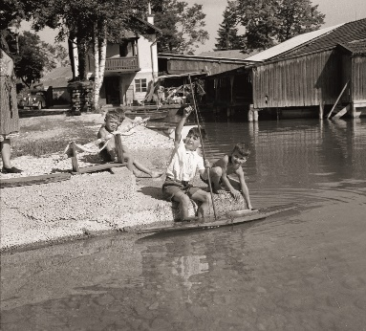 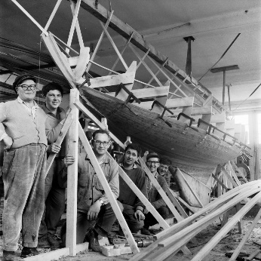 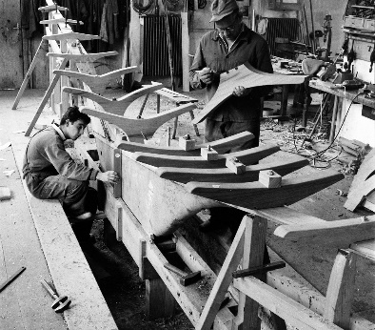 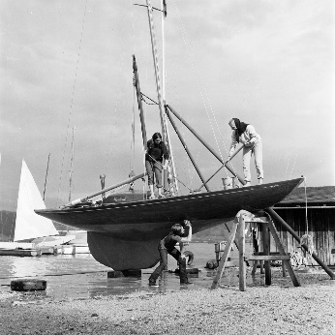

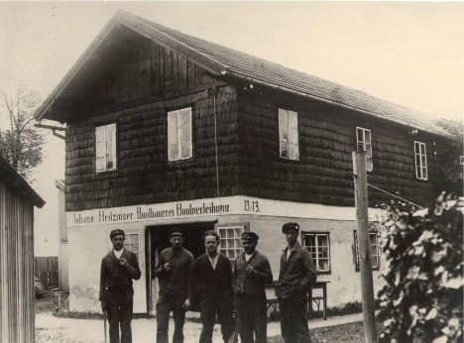 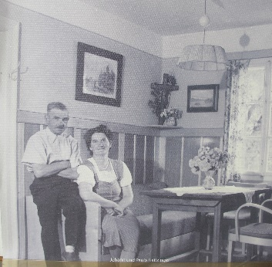 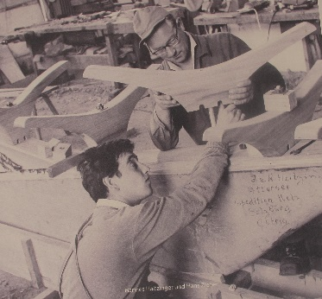 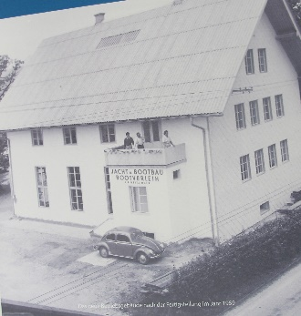

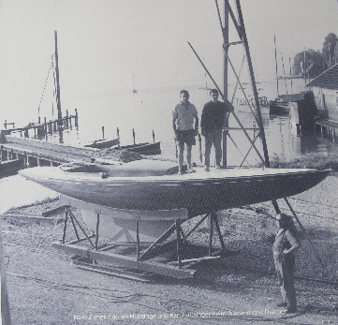 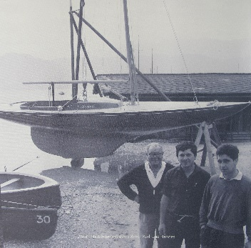

Archiv Haitzinger

### Johann Ratz (1963)

In 1894, Johann Ratz founded a "Yacht and Boat Yard" in St. Gilgen, which was soon known for the special quality of its work. At the end of the 50s, Johann Ratz, the son of the founder, a member of the UYCWg, bought an Abeking&Rasmussen, built in 1937 and registered the boat with the number OE 2 and the name ADRIENNE. In 1963 and 1964, two new buildings were built at the Ratz shipyard in St. Gilgen: AUT 6 HELESTA and AUT 7 CHERIE. Both boats are still sailing at UYCAs on Lake Attersee. After the death of Johann Ratz Senior in October 1964, the shipyard was closed.

Pictures of Ratz:

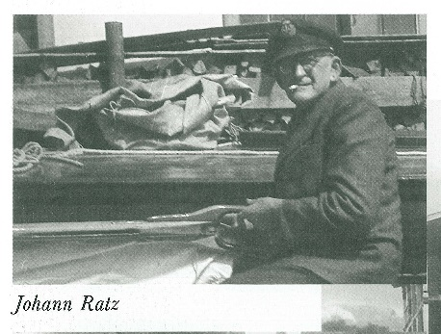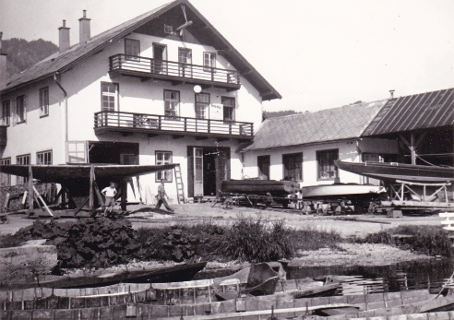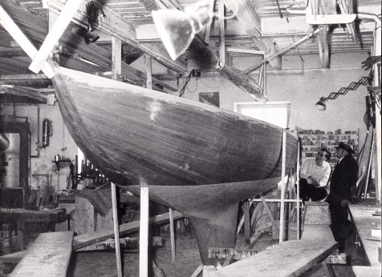

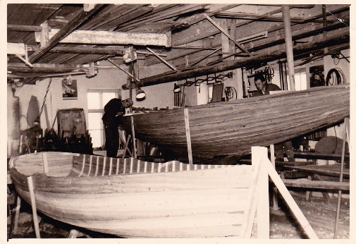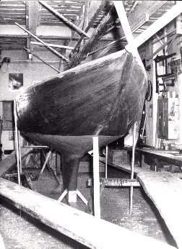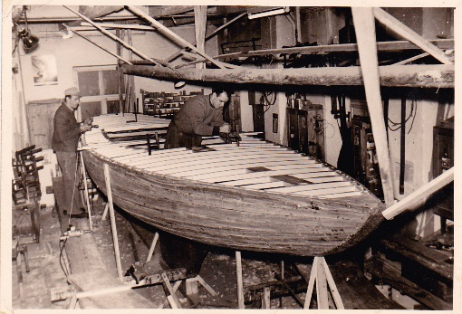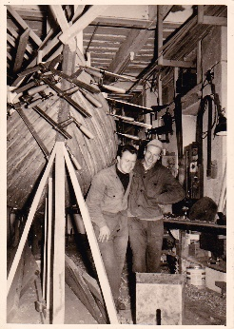

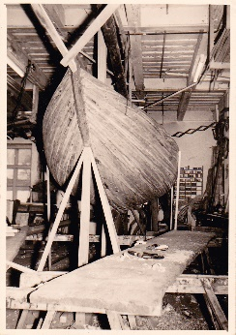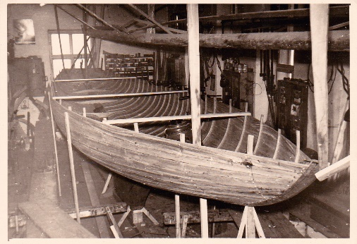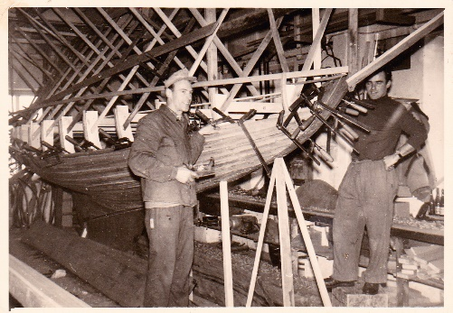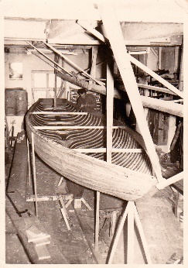

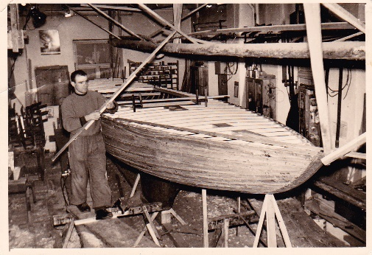

Sammlung Heli Winkler

## Switzerland

Switzerland – Register 2017

|  |  |  |  |  |  |  |  |
| --- | --- | --- | --- | --- | --- | --- | --- |
|  |  | Name | Shipyard | Year of construction | Yacht register | Registered owners | Club |
| ON | 1 | MAENNI | - | - | - | A. Büchi | YCS |
| ON | 2 | - | - | - | - |  | ? |
| ON | 3 | LIGHT | - | - | - | Mr. Labourdette | CVL |
| ON | 4 | CALINO | - | - | - | Neuhaus Sailing School | TYC |
| ON | 5 | URSEL | - | - | - | Dr. Ehrat | YCS |
| ON | 6 | KALYPSO | F. Rohn | 1955 | 1960 | P. Oberländer/K. Schönberger | YCRo |
| ON | 7 | YLÈNE | F. Rohn | 1955 | 1965 | P, Widmer | TYC |
| ON | 8 | ALAND | - | - | - | P. Bindschedler | ZSC |
| ON | 13 | MONSOON | Savoy cabbage | 1956 | 1956 | Hans Wirz | YCRo |
| ON | 14 | JOY I | Miller | 1956 | 1956 | V. Muzzolini / W. Kormann | TYC / ? |
| ON | 15 | YEAR | E. Stäheli | 1956 | 1965 | F. Vollenweider | SGYC |
| ON | 16 | WIND | Savoy cabbage | 1956 | 1959 | W. Hirt | YCRo |
| ON | 17 | CAPRICE | Miller | 1959 | 1959 | B. Maeder | Lake thun |
| ON | 18 | EAST | Miller | 1958 | - | W. Barben / J.+S. Posthumus-Zürcher | TYC |
| ON | 19 | MILAN | Miller | 1958 | 1959 | P. Werthemann | - |
| ON | 20 | - | Savoy cabbage | 1959 | 1964 | H. Jegge | Lake Zurich |
| ON | 21 | SIRIUS | Savoy cabbage | 1960 | 1967 | H. Zepf | YCS |
| ON | 22 | LAFLORE | Miller | 1960 | 1960 | H. Dickmann | TYC |
| ON | 23 | LAILA | Miller | 1960 | 1960 | F. Wyss | - |
| ON | 24 | AEGINA | Savoy cabbage | 1960 | 1965 | M. Nagel | SGYC |
| ON | 25 | HOBBY | Savoy cabbage | 1960 | 1964 | W. Scheuner | TYC |
| ON | 26 | GISCHT / MOANA | Miller | 1960 | 1985 | K. Birrer / C. Wigger | Zugersee |
| ON | 27 | HOPE II | Abeking&Rassmussen | 1960 | 1960 | H. Hoffmann | TYC |
| ON | 28 | SKYLLA II | Savoy cabbage | 1961 | 1973 | F. Güntensberger | YCL |
| ON | 29 | ARUBA / SCREWDRIVER | Burmester | 1949 | 1970 | B. Baldinger / B. Lüthy | YCS / ASC |
| ON | 30 | BACCARAT | Bjarne Aas | 1960 | 1960 | Goulandris, Thomas | SNG |
| ON | 31 | SCALAVE / PIROUETTE II / MARIANN | Savoy cabbage | 1961 | 1961 | W. Forster / P. Wülser | TYC |
| ON | 32 | WIND CHIME | Savoy cabbage | 1961 | 1961 | R. Schäppi / D. King | Zugersee |
| ON | 33 | ITHACA | Savoy cabbage | 1961 | 1961 | Dr. H. Gwalter | YCR |
| ON | 34 | GIOIA II / BRUNI | Miller | 1961 | 1961 | V. Muzzolini / G. Meyer / D. Waelchli / R. Bernhard | Lake thun |
| ON | 35 | ELFENAU | Miller | 1961 | 1961 | E. Spycher / R. Spring | Lake thun |
| ON | 36 | TELL | Savoy cabbage | 1961 | 1965 | E. Stierli | - |
| ON | 37 | GARGANTUA | Rambeck | 1957 | 1973 | P. Bülhoff / T+T. Willy / A. Wehrle | Lake thun |
| ON | 38 | SCIROCCO / BELLE PASSANTE | Savoy cabbage | 1962/1963 | 1975 | H.U. Schwendimann / J.P. Jenni / P. Rappaz | Geneva |
| ON | 39 | MEMORY | - | - | - | H. Straub / J. Steiner | Lake thun |
| ON | 40 | WIBITTE | - | - | - | Jordy | - |

### Bootswerft Müller AG (1946 – 1966)

The second largest Dragon shipyard in Switzerland is the Müller AG shipyard in Spiez on Lake Thun. Between 1946 and 1966, the shipyard built 66 Dragons in classic Carvel construction.

In 1954, Virgilio Muzzolini, known as "Muz", the architect of Bern's Wankdorf Stadium "The Miracle of Bern", received his first Dragon GIOIA I Z 14 from the Müller AG shipyard. As early as 1955, the Lake Thun Yacht Club, TYC recognised the Dragon as a class and promoted it. In the years from 1956 to 1958, the Dragons LEVANTE Z 18, MILAN Z 19, LAFLORE Z 22, LAILA Z 23 and HOBBY Z 25 were launched on Lake Thun and sailed their first-class regattas.

In 1959/1960 "Muz" was a co-founder of the Lake Thun Dragon Fleet and 10 years later of the Swiss Dragon Fleet and successfully participated in national and international regattas with his yachts. After more than 65 years, the grandson of "Muz", Paul Kreis, is also loyal to the Dragon Class and sails GIOIA SUI 317 in Switzerland at regattas and with the family. As Vice-President, he is firmly connected to the Swiss Dragon Fleet, like his grandfather.

Wooden Dragons by Müller

|  |  |  |  |
| --- | --- | --- | --- |
| 1934 | OUT 11 / OUT OF 57 | TYPHOON | Karweel |
| 1936 | Out of 52 | SIGHIGNOLA | Karweel |
| 1954 | Out of 14 | JOY I | Karweel |
| 1959 | Out of 17 | CAPRICE | Karweel |
| 1958 | Out of 18 | EAST | Karweel |
| 1958 | Out of 19 | MILAN | Karweel |
| 1960 | Out of 22 | LAFLORE | Karweel |
| 1960 | Of 23 | LAILA | Karweel |
| 1960 | Out of 26 | GISCHT / MOANA | Karweel |
| 1961 | Out of 34 | GIOIA II / BRUNI | Karweel |
| 1961 | Out of 35 | ELFENAU | Karweel |
| 1962 | Out of 44 | GYPSY | Karweel |
| 1963 | Out of 54 | PLEASURE | Karweel |
| 1963 | Out of 55 | STELLA MARIS | Karweel |
| 1963 | Out of 56 | JOHNNIE WALKER | Karweel |
| 1964 | Out of 64 | BOLD | Karweel |

### Yachtwerft Wirz AG (1955–2003)

It all began in 1955 in a small barn in the fishing village of Steinach on Lake Constance. Hans Wirz built his first Dragon for a customer. The trained precision mechanic developed a special love for elegant sailing yachts made of the finest woods. As a result, the Hanz Wirz Yacht Shipyard was born. Over the course of 65 years, over 200 Dragons were built there. The last one went to a new owner in Austria in 2003 as "cold moulded". In 2021, Yachtwerft Wirz AG was still family owned. Unfortunately, new Dragons are no longer built, but a proven team of specialists gives satisfied customers the certainty that their Dragons will continue to have the best care in the future.

Wooden kites from Wirz

|  |  |  |  |
| --- | --- | --- | --- |
| 1955 | Out of 13 | MONSOON | Karweel |
| 1957 | Of 16 | WIND | Karweel |
| 1959 | Out of 20 | BOREAS | Karweel |
| 1960 | Of 21 | SIRIUS | Karweel |
| 1960 | Out of 24 | AEGINA | Karweel |
| 1960 | Out of 25 | HOBBY | Karweel |
| 1961 | Z 28 | SKYLLA II | Karweel |
| 1961 | Z 31 | SCALAVE | Karweel |
| 1961 | Z 32 | WIND CHIME | Karweel |
| 2003 | AUT | - | Cold moulded |

Pictures of Wirz:

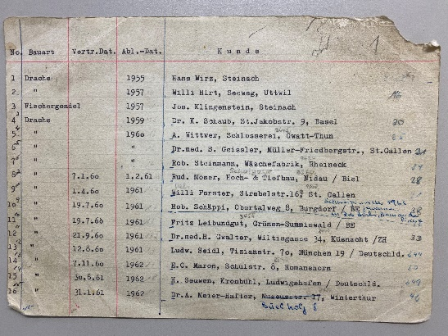

*Wirz Shipyard Book*

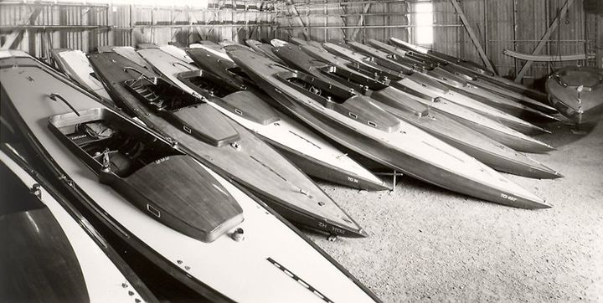

*Wirz winter camp – Picture Wirz boatyard*

Paths of a Savoy Dragon: ARJADNE Z 69, built by Wirz in 1963, becomes ERAGON HUN 38 in 2013/2014

Letter from Hungary: I am happy to inform you that the restoration work on the Dragon Z 69 ARJADNE of the Lake Thun Yacht Club has been completed. The restored boat was given a Hungarian number HUN 38 and a new name ERAGON from the book "The Legacy of the Dragon Riders" by Christopher Paolini. The restoration period took a long time and required a lot of patience. We repaired the broken wooden parts (there were fewer than we originally thought), removed the seats, replaced the deck with a teak deck, installed some parts to improve hull stability and ERAGON got a brand new, regatta compatible rig but kept the wooden mast. I am sure that ERAGON is the most beautiful classic Dragon on Lake Balaton. Since 2014 we have been trying to familiarize ourselves with the boat. I am lucky enough to sail with my two sons, Bence and Gergo. I would like to thank the Swiss Dragon Fleet for their help. It was very important to me that all the papers from the boat were clear and OK.

Thank you very much again! Tamas Domokos, ERAGON HUN 38

Dragon LUCKY, Z 58, Wirz 1963, today AUT 184

The Dragon Lucky was built in 1963 as hull number 58 by the Wirz shipyard. Under the name d'Àrtagnan, sail number Z58, the boat is sailed on Lake Zurich and won several prizes. In 1967, Robert Sonderegger took over the boat and brought it to Bottighofen on Lake Constance. In 1980, the boat changed ownership and went to Dr. Klaus Fehrmann from Constance. He renamed the boat Lucky. Under the sail number G-584, Dr. Fehrmann took part in several regattas. On one of the first outings, however, the original, dry-rotted wooden mast broke. In March 2010, the Dragon came to Lochau and has been sailing under the sail number AUT 184 ever since. After the second sailing season, only a cosmetic renovation is planned (a new shingle deck and a new paint job of the hull), but in the end it will be a general renovation lasting one and a half years with all its ups and downs. Segler's joys and sorrows are often close together...

## International

### Anker & Jensen (1930)

Christian Jensen founded his shipyard in 1888 in Vollen, Asker, about 30 km southeast of Oslo. Johan Anker initially worked as a design engineer at Jensen. In 1905, he acquired shares in the shipyard and eventually became a partner of Jensen in what is now the Anker & Jensen shipyard. However, Jensen lost interest in 1915, and Anker bought Jensen's share, including the shipyard name "Anker & Jensen". By the time it closed in 1952, about 450 sailing yachts had been delivered. From 1930 to 1952, Anker & Jensen built 48 Dragons, 39 of them until Johan Anker's death in 1940.

The first Anker & Jensen Dragon was delivered in Oslo in 1930 with the sail number 20 N 4 and the name "Rollungen". Johan Anker died in 1940, and the shipyard was initially leased to the employees Christian Engebretsen and Gunerius Larsen. The last Anker & Jensen Dragon was delivered to Denmark in 1952 to the customer Bror van der Lippe.

Pictures of Anker & Jensen:

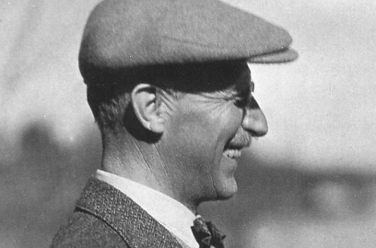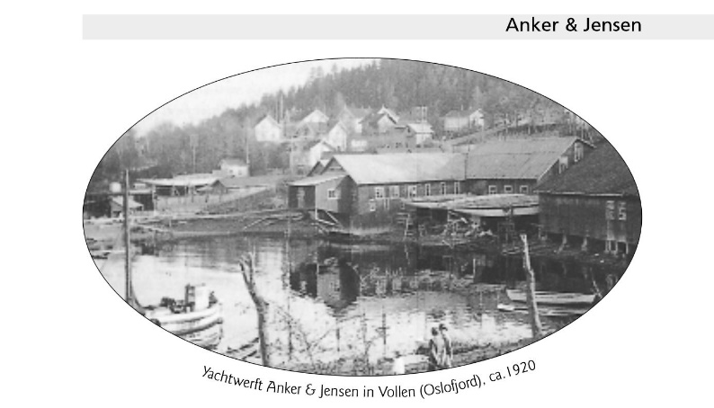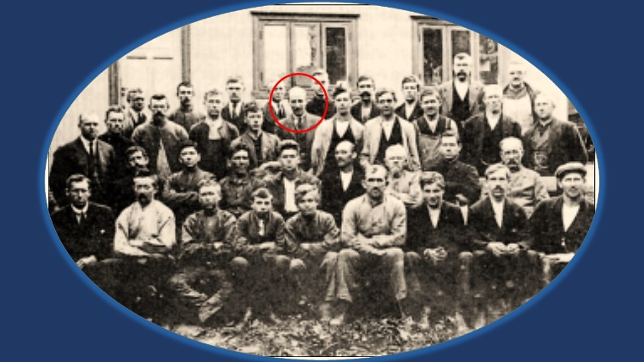….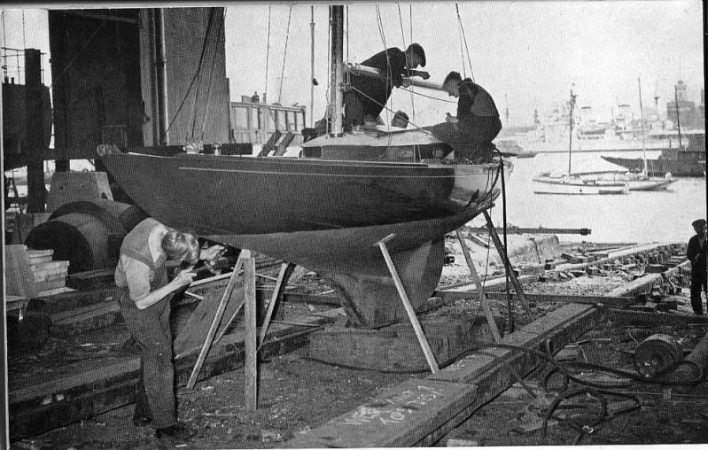

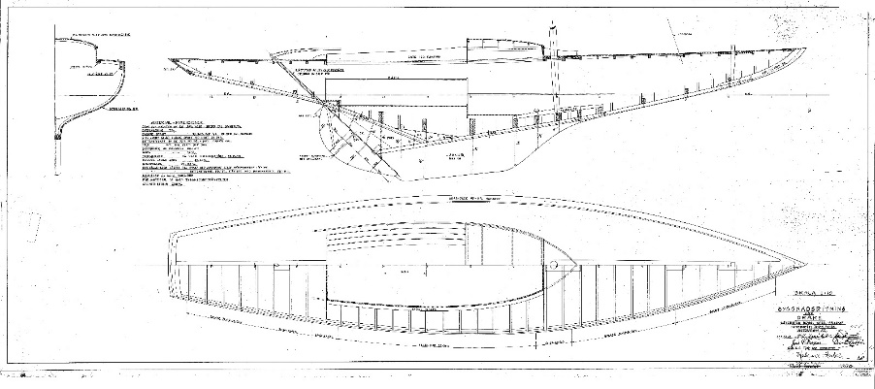

### Børge Børresen, Denmark (1935 - 2006)

The brothers Børge and Albert Børresen built their first Dragon in the winter of 1935/36. Borge, 16 years old, had just started as an apprentice in a boatyard. Albert, 21 years old, was a trained carpenter. Their father Peter Børresen owned a boatyard in Vejle. He died in 1920. There was nothing left of the shipyard, so the brothers built the Dragon in their spare time in an open shed.

In 1938, the first workshop with space for a boat was built. Albert died in 1948, and Borge (BB) continued to run the shipyard with the help of the family. They built Dragons, 5 meters, but also many other types of boats such as motorboats, junior boats, dinghies (40 Finns for the Helsinki 1959 Olympics) 5.5 meters, swallows, Nordic cruisers, LA cruisers, Knarrs and BB10.

The focus was on Dragon building: 325 Dragons made of wood, first of pine and later of mahogany, were built. In the years 1971-72, Børge worked out the basis for a Dragon made of fiberglass with the same weight and weight distribution as a wooden boat.

From 1969, Børge's sons Ole and Anders worked with him at the shipyard and became owners in 1982. Since 1972, they have been building Dragons and BB10s from fiberglass. In the following years, the Børresen shipyard built the Yngling, the new boat of the Olympic Games, and also wooden Dragons again, but this time in cold moulded construction.

Between 2004 and 2006, the shipyard ran into financial difficulties and had to file for bankruptcy. The rights to continue building Dragon under the BB logo were taken over by Royal Denship, but they could not prevail in Dragon building.

### Pedersen & Thuesen (1952-1970)

If the Dragon is considered the Bugatti of the Sea, then those of Pedersen & Thuesen are the Veyrons among them. The shipyard was founded in 1949 by Børge Pedersen and Poul Thuesen in Kolding, Denmark and initially built sports rowing boats, cruising yachts and motorboats of noble quality. From 1952 to 1970, 97 Dragons were built, of which at least 60 are still preserved today. The list of victories achieved with Pedersen & Thuesen dragons is impressive. Even today, restored Pedersen & Thuesen Dragons are considered to be on a par with modern fiberglass Dragons. In 2014, Lars Hendricksen won the European Championship with a Pedersen & Thuesen built in 1960. Contrary to many rumours, however, this is not a historically tolerated speed advantage, but Günter Ahlers, chief surveyor of the IDA, puts it unequivocally: "If ever real Dragons have been built, then it is the yachts of Pedersen & Thuesen. In the eight Pedersen & Thuesen that I completely measured, all the survey points were exactly in the middle of the tolerances, just as Johan Anker designed the boat." Unfortunately, the shipyard withdrew from Dragon construction in 1970 with the advent of GRP and continued to build mainly cruising yachts until 1983.

Pictures of Pedersen & Thuesen:

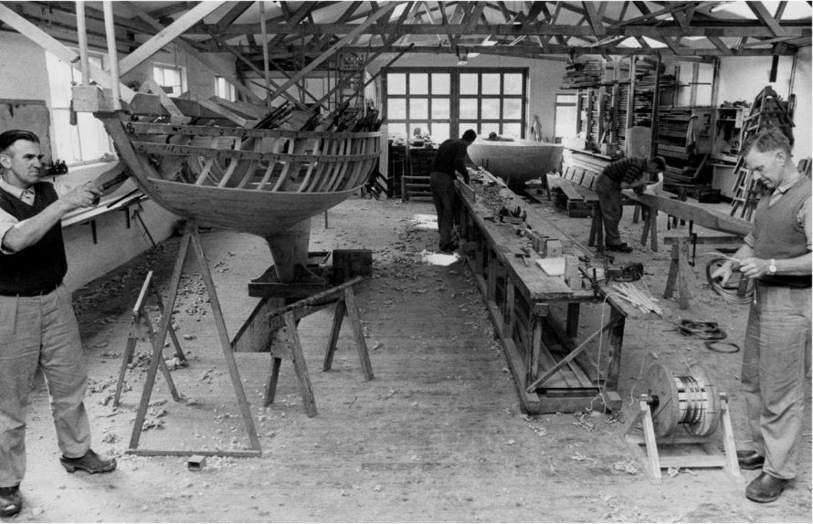

*Børge Pedersen and Poul Thuesen in their works in Kolding, Denmark. Photo: Tim Wilkes*

# Mikko's List

The Finnish dragon sailor Mikko Jaatinen obtained yacht registers from as many national class associations as possible and carefully entered the shipyards and boats. As he explained to us later, the winters in Finland are long and dark and such work is just the right thing to shorten the waiting time for the next season. The list may not be complete and correct, but we don't want to withhold it from our readers. Dubious or unverifiable entries are marked with a "?". So, there is still a wide field of activity for dragon researchers.

|  |  |  |  |
| --- | --- | --- | --- |
|  | **Years** | **Wharf** | **Location** |
| **FROM** | 1948 | J.H.Linnacre | ? |
|  | 1950-1955 | J. J. Savage & sons Pty. Ltd. | Williamstown Melbourne |
|  | 1951 | A. Rose | Melbourne |
|  |  | J.Griffin | Sydney |
|  |  | P. Derby | Melbourne |
|  | 1951-1963 | G.L Bate | Sydney |
|  | 1952-1964 | A. Jarman | Sydney |
|  | 1953 | F. Grove | Sydney |
|  |  | G. Riddell | Sydney |
|  |  | Gerrard | Victoria |
|  |  | J.B. Searle | Geelong Victoria |
|  |  | T. Fisher | Sydney |
|  | 1954 | C. Morrow | Sydney |
|  |  | John? Muston | ? |
|  |  | Ronstan Marine Equipment Pty Ltd | Melbourne |
|  | 1954-1957 | A.W. & G. Cuthbertson | Tasmania |
|  | 1955 | A.H. More | Sydney |
|  |  | C. Perry | Sydney |
|  |  | G. Stewart | Melbourne |
|  |  | K.R. Gourley | Hobart |
|  |  | T. Gowland | Sydney |
|  |  | W. Green | Melbourne |
|  | 1956 | E. Wall-Smith | Melbourne |
|  |  | Higgs Brothers | Geelong |
|  | 1956-1958 | S. Ferguson | Sydney |
|  | 1956-1965 | Billy William H. Barnett Pty Ltd. (Bronco Bill) | Sydney North |
|  | 1957 | A. Rowe (Athol?) | Waterloo |
|  |  | M. Greese | ? |
|  | 1959 | A. Wilson | ? |
|  | 1961-1968 | Norman R. Wright & Sons | Brisbane Queensland |
|  | 1962 | E. Spring-Brown | Sydney |
|  |  | E. Thomas | ? |
|  | 1962-1975 | Bellarine Marine Jim Sim | Bellarine |
|  | 1963 | J.C. Bridge ? | ? |
|  | 1964 | Lars Halvorsen | Sydney |
|  | 2004-2010- | Daryl (Zane) Ridgeway | Tasmania |
|  | ? | Atlatt ? | ? |
|  |  | Cox | ? |
|  |  | Endeavour | Australia NSW |
|  |  | Hampton | ? |
|  |  | J. Gutierres | Melbourne |
|  |  | Maalee Steve Ward | Perth |
|  |  | Masters Cavill | ? |
|  |  | Pilkongton | ? |
| **Car specs** | 1963-1964 | Johann Ratz | St.Gilgen |
|  | 1963-1970 | J&K Haitzinger | Lake Attersee |
| **BEL** | 1937 | Kuypers Shipyard | ? |
|  | 1963 | Antwerp? | Antwerp |
| **CAN** | 1956 | Robert Davis Boat Yard Co. | Oakville, Toronto |
|  | 1957 | Victor & Hazel Carpenter | Parry Sound Georgian Bay |
|  | 1958 | G.R. Hughes | Toronto Ontario |
|  | 1963-1964 | Abbot Boat Co | Sarnia Ontario |
|  | 1970-1985 | Marty Godsil | Pacific Northwest |
|  |  | O.E. Schuppe | Ontario |
|  | 1994 | Woodwind Yachts | Nestleton Ontario |
| **THE** | 1931-1936 | Broderna Andersen Skibsvaerft -> K.R.A. | Frederiksund |
|  | 1932-1940 | Fredriksund Shipyard | ? |
|  | 1932-1949 | Georg Andersen | Horsens |
|  | 1935 | Århus Yachtvaerft | Aarhus or Copenhagen (?) |
|  | 1935-1950 | Svendborgsund Shipyard? | Svendborg |
|  | 1935-2006 | Børresen Bådebyggeri ApS | Vejle |
|  | 1937 | H. Henningsen Rantzausminde Bådevaerft | Svendborg |
|  | 1938 | Jacob Svendsen Verft | Refshaleøen |
|  | 1938-1954 | A. Jensen & Son (Jens Peder Alfred Jensen & Knud Jensen) | Roskilde |
|  |  | Viggo Hansen | Kastrup |
|  | 1940 | Guhl ́s Laursen (Larsen?) | Copenhagen |
|  | 1943 | Viggo Jensen | ? |
|  | 1944 | Øle Madsen | ? |
|  | 1945 | Hans Møller - Marinus Møller Boatyard Skælskør | ? |
|  |  | Jens Hansen | Roskilde |
|  |  | Richard Grundsted | Odense |
|  | 1945-1946 | Hansen | ? |
|  | 1947 | Knudsen Jyllings | ? |
|  | 1947-1950 | Olof Jeppesen | Fredrikssund |
|  | 1948 | E. Knudsen & Sons | Jyllinge |
|  |  | Kalundborg | ? |
|  |  | Middlefart | ? |
|  | 1949 | Odense yacht yard | Odense |
|  |  | Thomsen Kalundsborg Denmark? | ? |
|  | 1949-1957 | Henry Rasmussen | Svendborg |
|  | 1950 | Egon Nielsen Nakskov Bådevaerft | Nakskov |
|  |  | Skjodt | Silkeborg |
|  | 1951 | Beautpaalsens | Sundby |
|  | 1951-1958 | A. (Aage) Walsteds Bådevaerft | Thurö Svenborg |
|  | 1952-1970 | Pedersen & Thuesen | Bramdrup dam |
|  | 1954 | Aage Birch | Humlebaek |
|  | 1957 | Ch. Hansen | ? |
|  |  | Nolds Boatyard | Nolds |
|  | 1960 | E. Hansen | ? |
|  |  | H. A. Jensen & Co. Boatbuilders Inc. A/S Hillerød (Hillmer Jensen) | Roskilde |
|  | 2004-2005 | Royal Denship | Vejle |
|  | 2006-? | Royal Dragon - Vejle Yacht Service Aps | Vejle |
|  | unknown | A. Ustrup | Vejle |
|  |  | Ejar-Jensen | ? |
| **ESP** | 1961 | Corsi Lengths | Vigo |
| **EAST** | unknown | Dragon Tallinn | Tallinn |
| **END** | 1947 | Valkon Laiva Oy | Lovisa |
|  | 1949 | G. Blomqvist's boatbuilding | Porvoo |
|  | 1949-1957 | Unto &; Onni Kaskinen | Turku |
|  | 1951 | Turku boatyard - Åbo båtvarf | Turku |
|  | 1952 | Kilpi & Kumppani | ? |
|  | 1955-1960 | Salmisaari boatyard /Rainer Lindgren | Helsinki |
|  | 1956 | Oh Telva Ab | Helsinki |
|  | 1958 | Wilenius båtvarv Ab | Porvoo Borgå |
|  | 1960-1969 | Nils & Paul Andersson boatbuilding | Kråkö |
|  | 1966 | Fortune Guard | Helsinki |
|  | 1967 | Heinävesi boatyard | Haywater |
|  | 1995 | Sam Hartikainen | Helsinki |
|  | 1995-2001 | Pentti Salminen | Helsinki |
|  | unknown | Halima Ltd | Kangasala |
|  |  | Oy Vator Ab | Helsinki |
| **FROM** | 1949-1959 | Macario Shipyard | Trouville |
|  | 1950-1968 | Chantier G. Bonnin frères | Arcachon |
|  | 1951-1956 | Pouvreau site | Vix La Rochelle |
|  | 1952-1955 | Hamel shipyard | Le Havre |
|  | 1952-1959 | Hervé shipyard | La Rochelle |
|  | 1954 | Barrier site | Arcachon |
|  |  | Georges Silvant Shipbuilding | Conflans-Sainte-Honorine |
|  | 1955 | De Coninck | Maisons-Lafitte |
|  | 1961 | Chantier Ziegler | Dunkirk |
|  | 1962 | Lebel | ? |
|  | 1963 | Le Got shipyard | Plouguerneau Brittany |
| **GBR** | 1936-1951 | McGruer & Co Ltd. | Clynder Scotland |
|  | 1936-1952 | Alexander Robertson & Sons Ltd | Sanbank, Argyll, Scotland |
|  | 1938-1959 | Woodnutt & Co. Ltd. | St Helen, Isle of Wight |
|  | 1939 | Vosper & Company | Portsmouth England |
|  | 1947-1951 | Camper & Nickholsons Ltd. | Gosport, Southampton |
|  | 1947-1964 | Nunn Brothers Boatyard | Waldringfield Suffolk |
|  | 1948-1950 | Reg J. Prior | Burnham on Crouch |
|  | 1948-1959 | Tucker Brown & Co | Burnham on Crouch |
|  | 1949-1969 | Clare (C.W.) Lallow | Cowes Isles of Wight |
|  | 1951 | Thomas Robson, Robson Boat Builders Ltd. | South Shields |
|  | 1952 | J. Macken | ? |
|  |  | Lawrenson | ? |
|  | 1952-1964 | Burnes Boatyard | Chisester |
|  | 1958 | Autoyachts Ltd. (Ron Parham) | Gillingham |
|  | 1959 | C. H. Lavis & Sons | Exmoor |
|  |  | Fairlie Yacht Services | Scotland |
|  | 1960 | Francis Charles Morgan Giles shipyard | Teignmouth |
|  |  | Francis Deacon | Hamble River Southampton |
|  |  | R & W Clark | Cowes |
|  | 1961-1962 | Cowes Boatbuilding | Cowes |
|  | 1978-1994 | Peter Wilson | Aldeburgh Suffolk |
|  | 1988 | Petticrows Ltd. | Burnham on Crouch |
|  | 1992 | Aldeburgh Boatyard Company Ltd. Peter Wilson Fort Green Aldeburgh | ? |
|  | 1999 | Emworx | ? |
|  | ? | Small Craft Yacht and Boat Co | ? |
| **GER** | 1930 | W. von Hacht-Werft | Hamburg |
|  | 1932 | B. Wilke Werft | Keel |
|  | 1934-1939 | Franz Mello | Hamburg |
|  | 1934-1966 | Abeking & Rasmussen Shipyard | Lemwerder Bremen |
|  | 1938-1964 | Erich Schaal&Penick VEB | Berlin Köpenick |
|  | 1939 | Lanke Shipyard | Berlin |
|  | 1942 | Fr. Lürssen Werft GmbH & Co | Bremen-Vegesack |
|  | 1947-1950 | Mathiesen & Paulsen Jachtwerft Paulsen GmbH | Arnis |
|  | 1948-1949- | Scharstein Shipyard | Kiel Dietrichsdorf |
|  | 1949 | (Karl) Feltz-Werft GmbH | Hamburg |
|  |  | Burmester | Bremen |
|  | 1949-1951 | Böbs-Werft GmbH | Travemünde |
|  | 1950-1957 | Johannes Schlichting | Lübeck-Travemünde |
|  | 1950-1962 | Rambeck GmbH | Starnberg Starnberger see |
|  | 1950-1963 | (Ernst Jakob Mikael) Sattler Werft | Percha Starnberg |
|  | 1951-1962 | Beck & Söhne | Insel Reichenau |
|  | 1952 | A.Tatt | ? |
|  | 1952-1968 | Willy Lehmann | Woltersdorf |
|  | 1954 | At Schiffsverft | Rostock |
|  | 1955 | Neptun Werft GmbH & Co. KG | Rostock |
|  | 1956 | August Holdorf | ? |
|  |  | Heidtmann-Werft | Hamburg |
|  |  | Yacht and Boat Yard Hamburg | Hamburg |
|  | 1957 | E.Neumann | ? |
|  | 1957-1965 | Reinicke Shipyard | Spandau Berlin |
|  | 1958 | Buchholz | Berlin? Potsdam?,Greifswald? |
|  |  | Eberhardt Shipyard | Arnis |
|  | 1960-1961 | Death & Sohn | Bremen |
|  |  | J.FR. Dood&Sohn | Bremen |
|  | 1961 | Boat Builders Crafts Berlin | Müggel Spree Berlin |
|  |  | Production cooperative of the boat building trade Müggel-Spree | Berlin |
|  | 1963 | Bootswerft Simmerding GmbH & Co. KG | Starnberg Leoni |
|  | 1964 | E.Burkhardt | ? |
|  |  | Vertens Werft (Karl Vertens) | Löptin |
|  | 1965 | J.W.Heiligensee | Berlin |
|  | 1968 | Hirsch Shipyard | Prien |
|  | 1968- | Bootswerft Markus Glas GmbH | Pöcking-Possenhofen |
|  | 1970 | Yachtwerft Berlin Köpenick | Köpenick Berlin |
|  | 1975-1978 | Udo Seipolt Yachtsport GmbH | Starnberg Starnberger see |
|  | 1997 | Niendorfer Bootsbauerei Ulrich Schütte | Niendorf |
|  | 2009 | Bootsbau Liebner | Utting |
| **HKG** | 1989 | Lowell Chang | Hong Kong |
| **ITA** | 1947-1953 | Baglietto-Varazze | La Spezia |
|  | 1948 | Beltrami Yard | Vernazzola |
|  | 1949-1953 | Cabella | San Remo |
|  | 1950-1951 | Posillipo | Naples |
|  | 1952-1959 | Cantiere Nautico Donoratico Tre Snc | Donoratico |
| **JPN** | 1960-1961 | Katagai | ? |
|  | 1960-1963 | Okamoto | ? |
| **DOWN** | 1935-1961 | E.G. van de Stadt Scheeepswerf n.y. | Zaandam |
|  | 1937-1944 | The Ford Shipyard G. de Vries Lentch | Amsterdam |
|  | 1938 | Van Der Meer | ? |
|  |  | Wester | ? |
|  | 1940-1951 | Kraaler Zaan Dam | ? |
|  | 1941 | B+S (Baerveldt and Stapel) | Zaandam |
|  | 1943 | Van Dam | ? |
|  | 1944 | Stream? | ? |
|  | 1945 | Van Heyghen | ? |
|  | 1946 | Gebr. Cook | Other |
|  | 1947 | Hillegersberg | Rotterdam |
|  | 1948 | Gustowerft | Schiedeham |
|  |  | Of flour | ? |
|  | 1949 | Wed. K. Brouwer | Zaandam |
|  | 1953 | Victoria | ? |
|  | 1955 | Stutterheim (Edward?) | ? |
|  |  | Valentyn & Sonen | Lead? |
|  | 1996 | Avivina Doomernik | Tilburg, Zaltbommel |
| **NOR** | 1929 | Hvidsten Boatbuilding | Hvidsten |
|  | 1930-1953 | Anker & Jensen A/S | Vollen Asker |
|  | 1930-1955 | (Robert?) Holmen båtbyggeri A/S | Sandnessjøen |
|  | 1932-1962 | Kolbjørnsvik Crane & Slip (Werft&Slipp) | Arendal |
|  | 1933-1949 | Sigurd Herbern Båtbyggeri A/S | The Kid Oslo |
|  | 1935-1936 | Ekert Stenødegaard | Vestnes |
|  | 1935-1939 | Soon Slip & Boat Building | Soon |
|  | 1935-1959 | Sverre Førde & Co Boatbuilding | Ålesund |
|  | 1936- | Vesøya Båtbyggeri | Grimstad |
|  | 1936-1948 | Reidar Jørgensen & Vik | Grimstad |
|  | 1937 | Hans Large | ? |
|  | 1937-1951 | The Roland Brothers | Kristiansand |
|  | 1938 | Felttvet Boatbuilding | Soldier |
|  |  | Jan M. Lunde | ? |
|  | 1939-1968 | Bjarne Aas Ltd A/S | Fredrikstad, Østfold |
|  | 1940-1949 | Borge Bringsvær Verft AS | Fillet |
|  | 1943 | Vidar Johansen | ? |
|  | 1945-1957 | Hans Hansen | Sandar Vestfold |
|  | 1946 | Fritjof Thorwaldsen | ? |
|  |  | Henry Fuglstad | ? |
|  |  | Ole Klementsen | ? |
|  |  | Sam O. Berge | ? |
|  | 1947 | A. Mordal | ? |
|  |  | Knut Solberg | Stavanger |
|  |  | Nicolaysen & Nygaard | ? |
|  |  | O. Holmestad | ? |
|  |  | Odd Ånestad | ? |
|  | 1947-1957 | Anders Gjeruldsen Boatyard | Fevik |
|  | 1951-1952 | Westermoens båtbyggeri A/S | Mandal |
|  | 1952-1960 | Guests | ? |
|  | 1953 | Olaf Bergsagul & Paul Brekke | Stavanger |
|  | 1958-1961 | Ivan/Ivar Benson/Bentzen | Arendal |
|  | 1960 | Ivar Bentzen? | ? |
|  | 1962-1963 | Børsholmen Boatyard | Soldier |
| **POLE** | 1962-1963 | Gdansk Yacht Shipyard | Gdansk |
| **BY** | 1949-1963 | João dos Santos Brites | Lisbon |
| **ON** | 1935-1955 | Yachtwerft Portier AG | miles of Lake Zurich |
|  | 1936 | Fur Bootbau Ag | Thunersee Spandex |
|  | 1938 | Boesch Motorboote AG | Kilchberg Zurichsee |
|  | 1946-1956 | Bootswerft Müller | Spiez Thunersee |
|  | 1955 | Bootswerft Rohn AG | Twann-Wingreis Lake Biel |
|  | 1956 | (Emil) Stäheli & Tschumper Werft AG | Altnau Bodensee |
|  | 1961-1983 | Yachtwerft Wirz | Steinach Hocsee |
| **THEIR** | 1928-1948 | Hjalmar Johansson's boatyard | Långedrag Gothenburg |
|  | 1929 | Bernhard Pålsson Boatyard | Råå Vättern |
|  | 1932 | Hästö slipway & boatyard | Arkösund |
|  | 1933-1937 | Ålholmens varv AB (sounds like Bråvikens Varv) | Norrköping |
|  | 1935 | Arvidsson & Sons shipyard | Färjenäs Gothenburg? |
|  |  | Hjalmar Andersson | Gothenburg |
|  | 1939 | Arendals Boatyard Hjalmar & David Olsson | Hisingen Gothenburg |
|  |  | Svensson & Dahlström's boatyard | Karlstad |
|  |  | Sweden Yachts Co | Henån |
|  | 1939-1940 | Lysekil | Lysekil? |
|  | 1940 | Gösta Svensson | Lysekil |
|  | 1946 | E. & L. Hanson | ? |
|  | 1947-1948 | Anon Kittelsen | ? |
|  | 1948 | C.E.Andersen | ? |
|  |  | Torsten Abrahamsson & Son Färjenäs | Gothenburg |
|  | 1954 | Nice Holm Yachtcolor | Old Town |
|  |  | Walther N. Anderson | ? |
|  | 1955 | The Martinsson Brothers | Svineviken |
|  | 1955-1956 | Arvika yacht and boatyard | Arvika |
|  | 1959 | Oscar Schelin's Boatyard | Kungsör Mälaren |
| **UAE** | 2014 | Premier Composite Technologies LLC | Dubai |
| **UKR** | ? | Lagoon Royal | Kherson |
| **US** | 1949 | Nichols Brown´s Boat Yard | Miami Florida |
|  | 1957 | Superior Sailboats, Vic Carpenter | Port McNicoll, Michigan |
|  | 1963-1965 | Kevin Savell | San Diego |
|  | 1977 | Miller Marine Const. | ? |
|  | ? | Spoce O.E. Schupp III | ? |
| **?** | 1939 | G. Baary ? | ? |
|  | 1951 | Gay ? | ? |
|  | 1953 | Paul Bakken ? | ? |
|  | 1971? | Bottasar (Bottas)? | ? |
|  |  |  |  |